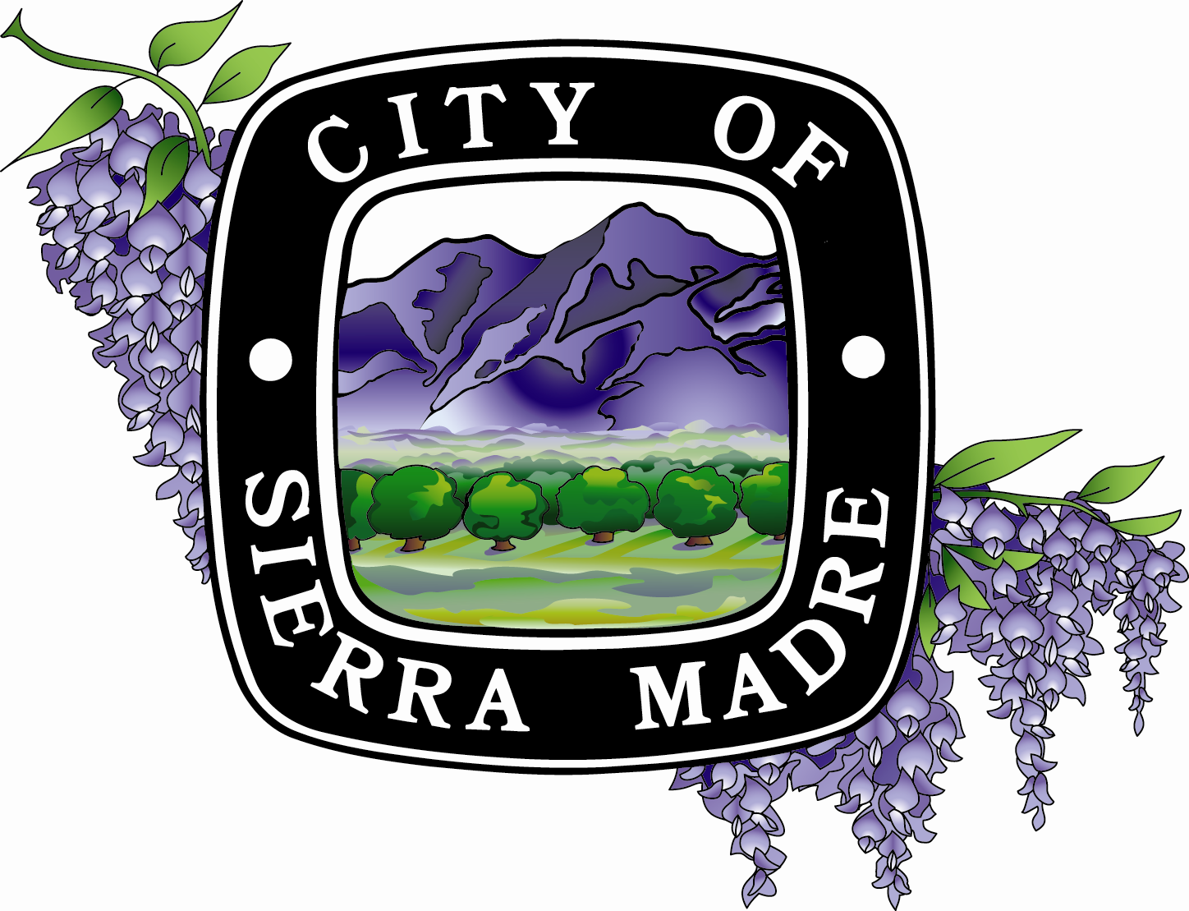
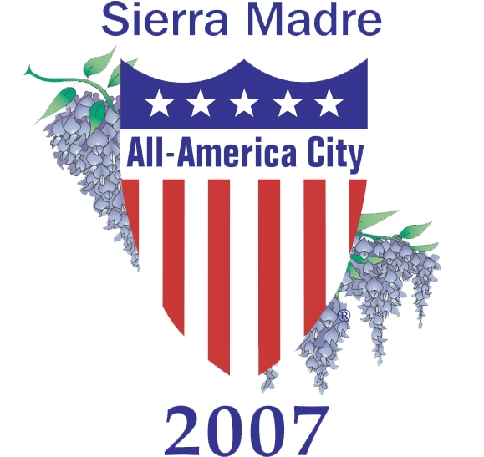
GET OUT! GET ACTIVE! VOLUNTEER!
Join the Team!




The City Council is seeking volunteers to serve on the
upcoming Green Advisory Committee!

The City is looking for motivated, enthusiastic, creative, and friendly volunteers to serve on this important committee to help promote the City’s goals of environmental conservation.

Green Advisory Committee (GAC)
The GAC is a five-member committee, appointed by the City Council. The GAC may be comprised of residents who are professionals in the field of environmental conservation, environmental sustainability, design professionals, or individuals who have a desire to explore “green” programs and practices that apply to future City development. A City Councilmember and/or Planning Commissioner could also be appointed to attend meetings to act as liaisons to their Council and Commission. The GAC meetings will also be attended by a City staff member.

What is the role of the GPSC?
The role of the GAC is to meet on a regular basis and will be asked to provide staff with recommendations and direction to further the City’s efforts on “green” practices and programs, such as energy efficiency, waste reduction, recycling, clean energy, sustainability, including monitoring compliance with State and regional statutes, and possible creation of a Green Building Ordinance for public and private development in Sierra Madre. The GAC’s role is solely advisory. Any recommended practice or program will be reviewed by the City Council acting upon the GAC’s and Planning Commission’s recommendations.

How much time is involved?
Participation on the GAC will require a commitment to attending monthly meetings (or on as-needed basis) for an approximately 18-24 month period. All regular GAC meetings will occur at pre-set meeting dates and times, and would be expected to last approximately two hours.

For an application, visit http://cityofsierramadre.com/docs_forms/files/application_commission.pdf
for Commission application
For more information please call (626) 355-7135 and ask for
Danny Castro, Development Services Director.

